Please Note:
You are reading a free sample excerpt (3 Free Poems) from the E-Book, Suicide: 19 Poems to “Beat Still My Heart,” by Beth Brown.
The E-Book is available for purchase at Amazon.
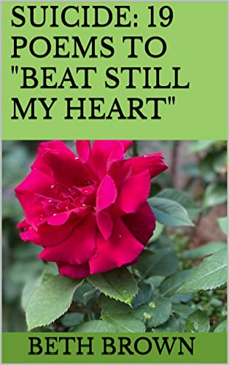

You are viewing a sample of the Kindle version

Suicide: 19 Poems to "Beat Still My Heart"

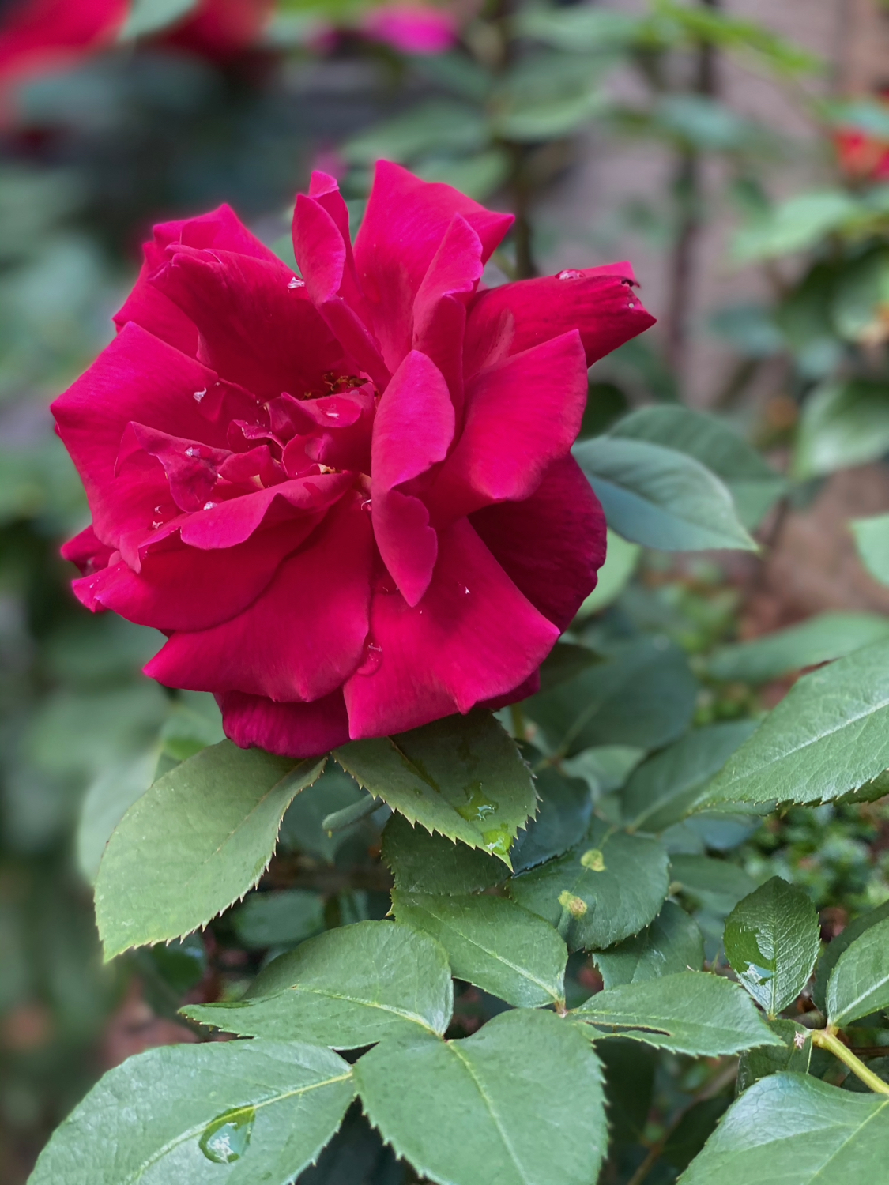A DEEP SORROW

I Will Seek Until I Find You
And where will you run when arms reach
(but you’re not mine)
When I can feel still so strongly
(holding you still in my arms)

From here frantic I search wildly
(but cannot ever now find)
Little one in pictures
(trying hard for one so young)

Standing, but not steady, little hand tucked inside mine
Holding on together climbing moonbeams to the stars,
Once upon a time ago—forever in my mind,
I thought us both impervious
(Against the ravages of time)

Oh little one where art thou
Whence I call you once again,
Dearest child, still my child on earth
(in a world so vast and big)
You've gone where I can't find you
(and seek still that which did exist)

If God can hear prayers from below
(and you can see me now)
Please know I miss you terribly
(and will seek until I find)
A way to hold you yet again
(your hand yet still tucked in mine)

When fire moon red bloodies
Little star that once was mine,
Deepest blue on blackest night
(I will seek until I find)
Little one beside me
(your hand tucked inside mine)

©Beth Brown, 2023

So Swish to Sway
So swish to sway to sweet lullaby,
Baby will fall in dark of the night.
Rocking cradle to grave turning truth upside down:
Parents die first leaving children behind.

In a world topsy-turvy that cannot make sense,
Sacred trust shines the brightest in a child’s innocence.
When children die first leaving parents behind,
Hope flees with the child leaving grief here for life.

To live without sorrow seems an admirable stance,
To love without pain always breaking your heart,
To smile again when it’s been enough time,
To heal back to whole what was once then your life.

Yet the loss of a child can’t be undone,
Even though bid us well, wishing hope move us on.
We can move only forward with our child whom we love,
Always there with us always, sorrow buried in love.

©Beth Brown, 2023

Bury My Heart
Bury my heart
I’ve come undone,
Sorting through this life
My son left behind.

And what I’m seeking
I know I’ll never find,
His touch, his smile—
His still living his life.

And so instead I sift through
A still-life dream,
My heart and life with him
Forever it seemed.

And oh my son
I’m still paralyzed,
In the grief you left me
A decade behind.

Where canst I go?
Whom canst I see?
When all I want with you
Is forever to be.

And how my heart keeps on beating
Is a mystery to all,
For without you beside me
I live suspended in time.

I live now life backwards
My heart beating in time,
To the life that we lived
When you, child, were mine.

Try as I might
I can’t seem to live,
For my dreams all belonged
To your future forward lived.

And so where now I goeth
And where knoweth I dwell,
Once again and all over
Life without you is hell.

I ache without breathing
For to breathe is to die,
Once again and all over
Without you in my life.

©Beth Brown, 2023

Excerpt Sample Above Is From The E-Book, Suicide: 19 Poems To “Beat Still My Heart” Available on Amazon.

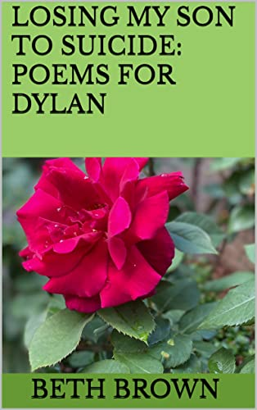

Suicide: 19 Poems to “Beat Still My Heart”

